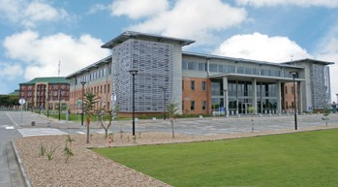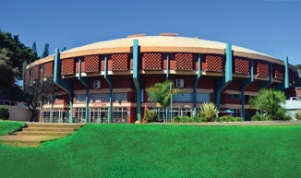

You are cordially invited to the
Event??
to recognise and celebrate excellence in 123456789

Date: 123456782019
Time: 123456789101112
Venue: Richards Bay Campus

Please indicate if you will attend with a partner and if you have any special dietary requirements
Dress Code: Elegant

RSVP to 1234567890
Tel: 035 902 6000
Email: CastleS@unizulu.ac.za

