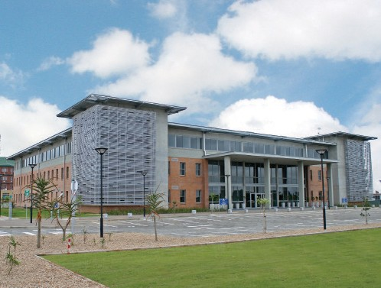
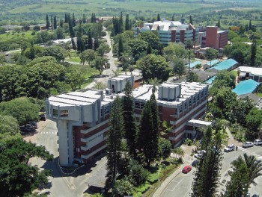

FACULTY OF ARTS
RESEARCH SEMINARS

Date: Wednesday, 31 July 2019 Venue: Arts Auditorium
Time: 12h30 - 14h00

Speaker: | Dr Maxwell Shamase, Department of History
Topic: | History as a compulsory subject in South African schools (2023 - 2025): Implications for Higher Learning Institutions
Discussant | Dr Mbusiseni Dube, Department of Social Sciences Education, Faculty of Education
Chair | Prof H Rugbeer, Department of Communication Science

RSVP: AkpomeA@unizulu.ac.za

“Light refreshments will be served”

UNIVERSITY OF ZULULAND

Restructured for Relevance

