Nguni Sheep in Kwa-Zulu Natal: A Valuable Food Resource, are we Losing it?

Introduction
Zulu sheep also known as Nguni sheep are found in different areas of Kwa-Zulu Natal Province. They are classified as a small breed and are predominantly reared by the rural farmers because of low cost required for maintenance, adaptability, to harsh environment and relative disease resistance. More than 67% of the historically disadvantaged livestock farmers in South Africa operate under a village production system, which is inherently isolated and lacking in resources and infrastructure. However, the existence of the Nguni breed is threatened because the numbers are declining. Various reasons have been established for the decline including the high mortality of lambs, severe draughts in some areas and diseases. Genetic studies showed that some of the sheep populations are highly inbred can be the cause of low productivity. However, the main threatening contributing factor is that of commercialisation. There is evidence of cross-breeding activities in some areas of Kwa-Zulu Natal. These activities are driven by the perception of some farmers that Zulu sheep are not a suitable genetic type for the current market conditions because they possess a small framed body. The crossbreeds require high cost maintenance but more significantly this will affect the existence of this valuable heritage.

The aim of the inauguration is to share’:

The significance of Zulu sheep
The production management system of Zulu sheep
The current population structure of Zulu sheep and in relation to exotic breeds.

Significance of Zulu Sheep
From an Asian origin, sheep spread westwards to beyond the Mediterranean, including Europe and Africa. The process of domestication resulted in some morphological and physiological modifications in sheep. For instance, wool replaced the hair coat in colder climates, the tail was lengthened and in some cases became a place of excess fat storage. The arrival of Nguni sheep with the Nguni people to South Africa has been traced back to between 200 and 400AD. One group is believed to have arrived on the east coast of KwaZulu-Natal and then dispersed further South depending on the suitable conditions for growing crops. The Nguni sheep of sheep of Swaziland are called Swazi sheep, The Landim are Nguni sheep that settled in Mozambique, the Pedi sheep in the northern province of South Africa. These sheep breeds are also termed the ecotypes of the Nguni sheep.

Zulu sheep are thus found over the entire KwaZulu-Natal province with larger populations in the northern part of the province at places such as Jozini, Msinga, and Nongoma. They are reared by farmers in the rural areas under an extensive type of management where they depend entirely on the natural veld for their nutritional requirements. This breed primarily serves as a source of meat and income to the poor rural farmers, at the same time providing a source of livelihood and means of utilising marginal environments not suitable for cultivation. Research flocks have been established in Makhathini Research Station near the Jozini dam and in the University of Zululand.

Zulu sheep have thin or fat tail but the significant feature is the ear length that vary from ear buds (gopher) to short prick (elf) ears to long pendulous ears (Fig.1). It has been speculated that the gopher ears probably assist in controlling the amount of infestation by the ticks.

/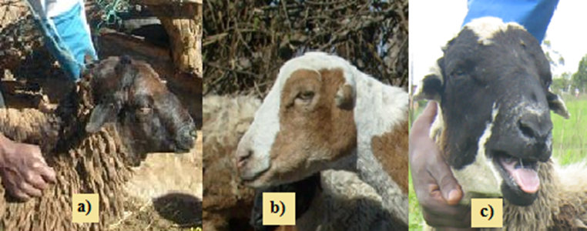

Figure1. Different types of ears found in Zulu sheep: a) natural ears, b) gopher ears and c) elf ears

The other feature is that of being multi-coloured and the dominant colours are dark brown and a dark brown-and-white colour combination. Brown or dark brown adult sheep are born as black lambs and the colour gradually changes to brown or dark brown as the lambs grow. The coat is mainly hair with a small percentage of wool. The skin is also used for making traditional wear.

The average weight of mature (2 years and above) female Zulu sheep is 33.4Kg and males is 39.1Kg. This is not comparable to the average weight of a Dorper ewe and ram (40kg and 74 Kg, respectively) or the Dohne Merino with average weight between 55 -80Kg for ewes and 50-105Kg for males. Although the systems of production or the environment have an influence, the size of these sheep breed is mainly controlled by the genes. Their small size simplifies the type of management because they have less nutritional requirements.

However, weights of Zulu sheep have been found to be less affected by the change of season although, the quality of forage in the natural pastures where they graze is low during the dry season. They are able to maintain their weight and even the body condition score between the wet and the dry seasons, without any supplements. While studying the foraging behaviour of this breed in five different areas of KwaZulu- Natal it was observed that in the dry season, the Zulu sheep increased the time spent on browsing (of shrubs and trees) thus have adapted a combination of grazing and browsing activities interchangeably. This breed must have developed this as an adaptation strategy to supplement their nutritional requirement because sheep are natural grazers not browsers.

However, it was noted that simple supplementation (maize Stover sprinkled with concentrates) of Nguni sheep during the dry season yielded positive results. An increase in weight of the lactating ewes by up to 5kg which resulted to improved weights of the lambs was realised. This is an indication that slight supplementation of this indigenous breed in the rural areas could improve their production. considerable i

Areas in KwaZulu- Natal are generally hot and humid and farmers have acknowledged that Zulu sheep cope well in this environment compared to the exotic breeds. During a survey on livestock production in rural KwaZulu-Natal, the rural farmers mentioned other reasons in rearing the breed to be the ability to tolerate both external and gastro-intestinal parasites as well as resist the tick-borne diseases. In addition, Zulu sheep are able to walk long distances in search of feed and water to drink. Other use include manure, skin, rituals and sales. The proportion of farmers who sold their sheep (57.3%) was greater than those who did not (42.7%). Most farmers were compelled by need to sell sheep and only a few had defined systems of marketing (e.g. selling rams when their numbers have increased). It has also mentioned by several farmers that the meat of the Zulu sheep has a supreme taste compared to that of other sheep breeds.

It is necessary to understand the fertility of the Zulu sheep rams as a requirement for an informed strategy for their conservation. Male fertility is an important factor for the survival of animal species, a fertility test by means of semen evaluation offers predictive information that may enhance the overall reproductive potential of the flock. Semen parameters of rams aged one to four years were studied in eight different areas of KwaZulu- Natal. The major difference found in this areas was the type of vegetation. The results showed that the area or geographic locations did not have an effect on the semen and spermiogramic parameters (semen volume, spermatozoa motility, spermatozoa concentration, live spermatozoa percentage) but it was rather the age of the ram. The quality of these parameters reached their optimum at three years old after which there was a decline. The season of year had an effect on the percentage of live spermatozoa, it was lowest in summer compared to spring, winter, and autumn.

Production systems
In the majority of areas of KwaZulu-Natal where Zulu sheep are found (Empangeni, Eshowe, Matubatuba, Escourt, Hlabisa, Jozini, Ingwavuma, Ulundi, Nongoma, Nquthu, Msinga), the sheep owners have 40 sheep on average; among the flocks, the highest proportion of livestock is the ewes (22%) and the lowest is the rams (3%). Nquthu had the largest average flock size (110.4±18.4) per farmer while Matubatuba had the smallest (8.0±2.6). Lambs constituted 15.7% of the average flock. However, the perception of the farmers is that the Zulu sheep numbers have declined but the cattle and goat numbers have increased. Although they do not keep records, from their speculation in a five-year period, the sheep had decreased by 7.5%. This is in line with various reports from the Government that the Zulu sheep numbers are declining.

Sheep graze collectively on communal grazing land during the day and are enclosed in kraals in the evening and majority of the farmers do not provide any supplements. About 92 percent of the sheep flocks travel a distance of over 1Km to water sources. A few of the flocks drink in the dams depending on the rains and even fewer homesteads provide drinking water to the sheep (Fig. 2).

Figure 2. Reported distance travelled by sheep to water sources in winter and summer

Most of the farmers (70%) started off with fewer than 4 sheep while only 10% started with more than 10 sheep. The sheep numbers have grown over the years from the same stock and breeding has been controlled in only 16% of the flocks by bringing new rams into the flock. The rest of the flocks have been bred by related animals indicating possible inbreeding in most of the herds. Severe inbreeding brings up bad genes such as stunting growth in sheep. It may also bring up odd diseases. In Nongoma it was found that the mortality of lambs was higher than in other areas. Over 80% of the farmers had the same problem. They did drench the lambs, because the assumption was that they were infested by internal parasites but it was not yielding positive results. During the survey, the pattern of inbreeding was identified as most of the initial stock of sheep for the farmers was obtained in the same place. Moreover, according to the areas where sheep were kept in Nongoma, the herds grazed communally (which is a common practise in rural farming), which may have increased the possibility that inbreeding had had an effect. The majority of the farmers, did not practice any means of controlling inbreeding.

History of cross breeding of the Zulu sheep with exotic breeds was also reported by 42% of the farmers. The reason given for crossbreeding was to improve the body weight of the sheep. However, in one of the areas (Nquthu) where sheep were reported to have been crossbred, the farmers also mentioned the need to vaccinate the hybrids (offspring of Zulu sheep crossed with exotic breeds) for external and internal parasites, fortnightly. This is highly frequent and costly compared pure Zulu sheep which are treated only when symptoms of parasitism are observed. A spray or a dip was used by 62% of the sheep owners for controlling external parasites. Gastro-intestinal parasites were predominantly controlled by drenching when it was found necessary. Some did not use any medication to control the internal and the external parasites. Zulu sheep received treatment for external (58.3% flocks) and gastro-intestinal (60.4% flocks) parasites when showing ill health.

More than 80% of farmers obtained medication for their sheep through private drug suppliers. Only 3.1% indicated that they sourced help from extension services and government veterinary while 12.5% had no access to veterinary help.

A high percentage of mortality of lambs followed by the ewes (mature females) was reported, the main source of death being drought and diseases. The lambs were also reported to have been killed by dogs and other predators and a small percentage (3.1%) by gastro intestinal parasites. When characterising the distances between ewes and lambs of Zulu sheep in the grazing areas from birth till weaning, we found that an increase in distance between the mothers and lambs is caused by the decrease of milk production and maternal role. The decrease in suckling and lying behaviour in lambs is encouraged by the increase in grazing, which will enable them to acquire nutrients to grow older. This increase in distance between lambs and their mothers as the lamb grows may be the cause of subjecting lambs to predation in places without shepherds. It has also been found that male lambs move too far from the ewe than the female lambs because they tend to look for sites with nutritional characteristics than safety from predators. This makes them more them more exposed to predation compared to female lambs

Structure of the Zulu sheep populations
- In relation with the other Nguni sheep
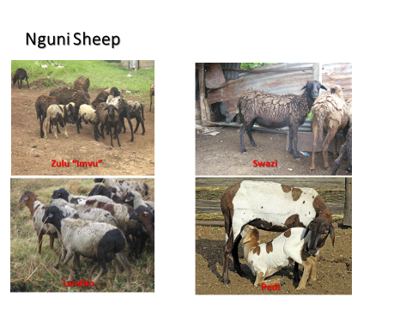
Figure 3. Type of Nguni sheep in Southern Africa
The four Nguni sheep types are multi coloured. The mean body weights for sheep were 30.41, 35.34, 35.23 and 37.63Kg for Swazi, Zulu, Landim, Pedi respectively.
Eight morphological traits were analysed to assess the relationship between Nguni sheep. Morphometric Cluster analysis in Figure 4 show that the Landim, Swazi and Zulu sheep in one cluster. The Pedi sheep were closer to the Dorper (a cross from Dorset Horn and the Blackhead Persian sheep and the second largest breed in South Africa) than to the other Nguni sheep.
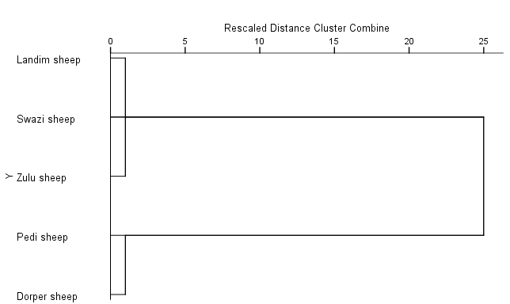
Figure 4. Morphometric clusters showing between Nguni sheep and the Dorper
Similarly, genetic analysis showed that the Swazi sheep formed a cluster with Zulu sheep and the Pedi formed a cluster with the Dorper. These results confirmed indications by other researchers that Pedi sheep are genetically distant from Zulu and Swazi sheep breeds. This could indicate that breeding the Zulu with Swazi sheep could be a possible conservation strategy to control inbreeding.
Fig.5 Genetic diversity between the Nguni and the Dorper sheep breeds

Genetic Population structure in relation to exotic breeds
UNIZULU sheep and Makhathini Research Station are genetically closer/ high genetic similarity. The sheep in these two areas have been protected from crossbreeding. However, Ulundi sheep population is more genetically closer to the Dorper breed while Nquthu and Matubatuba populations are genetically closer to the Merinos. Damara is distant from all the populations. Figure 6 show some evidence of having crossbred Zulu sheep with Dorper or Merinos in some areas.

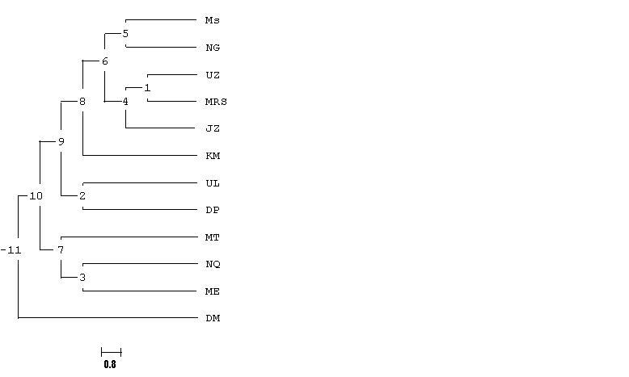

MS, Umsinga
MT, Matubatuba
NQ, Nquthu
KM, KwaMthethwa
UL, Ulundi
DP. Dorper
UZ, Unizulu
MRS, Makhathini Research Station
NG, Nongoma
JZ, Jozini
DM, Damara
ME, Merino

Figure 6 Genetic diversity between the Zulu sheep and the exotic breeds
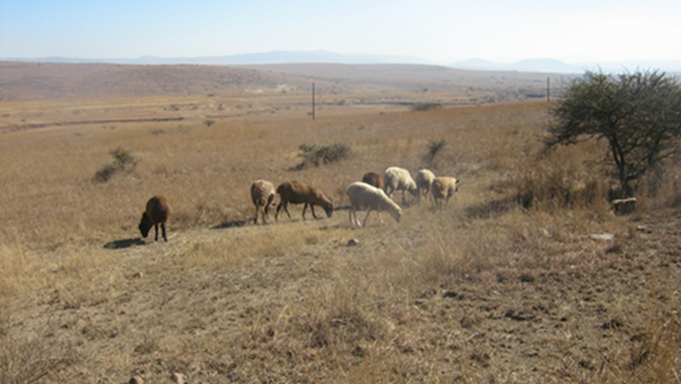

Figure 7. Mix of Zulu sheep and the Merino in the grazing area at Nquthu
Farmers in Nkandla and Nquthu were advised to join a Merino wool project which was to make them some money, but it was not sustained, rather Nguni sheep were diluted with genetic material of the Merino sheep due to cross breeding.

Inbreeding
The Inbreeding coefficients (F_{IS)} values (Table1) for the majority of the populations were positive indicating a high level of inbreeding. The Jozini and Nongoma populations were relatively highly inbred compared to the rest of the Zulu sheep, followed by the Nquthu and Ulundi populations.

Table 1. Inbreeding Coefficients indicating level of inbreeding

Breed  /population |  |  |  |  |  | F_{IS} [IC_{95%}]
JO |  |  |  |  |  | 0.16
MT |  |  |  |  |  | 0.09
NG |  |  |  |  |  | 0.13
ES |  |  |  |  |  | -0.01
UL |  |  |  |  |  | 0.11
NQ |  |  |  |  |  | 0.12
UZ¹ |  |  |  |  |  | 0.03
MS¹ |  |  |  |  |  | 0.06
DO |  |  |  |  |  | 0.06
DA |  |  |  |  |  | 0.07
ME |  |  |  |  |  | 0.04

JO-Jozini, MT Matubatuba, NG Nongoma, ES Eshowe, UL Ulundi, NQ Nquthu, UZ UNIZULU, MS Msinga, DO Dorper, DA Damara ME merino

Conclusion
This work has highlighted various reasons why there is a need for intervention to save or conserve the Zulu sheep. The National development plan 2030 has one of the important key areas of developing an inclusive rural economy by rising agricultural production, it further indicates that agricultural productivity is required to address food security at household and individual level. Providing dips and licks to the rural farmers could improve the production and health of the Zulu sheep. The need of extension officers to understand the problems and work with the farmers to provide solutions to help conserve Zulu sheep is essential. A program on the exchange of rams between the different areas to curb inbreeding is recommended. Areas with severe drought and water shortages need to be identified and assistance provided, as it is the cause of high percentage of mortalities. Therefore, a conservation strategy of Zulu sheep is essential, a plan was initiated by the Department of Agriculture Forestry and Fisheries (DAFF), on breeding the sheep at a station and giving back the rams to the farmers, but not much has taken place thus far. We plan to register the UNIZULU Zulu as a conservation flock but may be limited by space. It will also be considered to preserve the semen and the ova of the Zulu sheep while other plans are being executed.

The lower body weight of Zulu sheep implies that their market price may not be as competitive as that of other sheep breeds. However, their attribute of being adapted to the local harsh environmental conditions allows farmers to raise them at lower input levels. This renders raising the breed by the resource poor rural farmers more economically viable compared to the commercial breeds.

Acknowledgements
I would to acknowledge the funders for the projects:
NRF: National Research Foundation
DAFF: Department of Agriculture Forestry and Fisheries
ARC: Agricultural Research Council
The post graduates who collected the data in all the projects
The University of Zululand for providing the favourable environment research and academic growth
References
Chella L., Kunene N, and Lehloenya. 2017. A comparative study on the quality of semen from Zulu rams at various ages and during different seasons in KwaZulu-Natal, South Africa
Devendra, C. and Mcleroy, G.B. (1982) Goat and Sheep Production in the Tropics. Intermediate Tropical Agricultural Series, Longman Scientific and Technical Publishers, Longman, London, 218-219.
Dlomo, MZ. 2018 The Characterisation of some selected social behaviours of Zulu sheep. MSc Dissertation, University of Zululand.

Epstein, H. 1971. The origin of the domestic animals of Africa. Africana Publishing Corporation
FAO (2012). Phenotypic characterization of animal genetic resources. FAO Animal
Production and Health Guidelines No. 11. Rome.
FAO (2007). The state of the world’s animal genetic resources for food agriculture.
http://www.fao.org/docrep/010/a1250e/a1250e00.htm
Gwala P,E., Kunene N,W., Bezuidenhout C,C, and Mavule BS. 2015. Genetic and
phenotypic variation among four Nguni sheep breeds using random amplified polymorphic DNA (RAPD) and morphological features.

ILRI, 2007. Domestic animal genetic resource information. International Livestock Research Institute ed., Nairobi, Kenya. Available from: http://dagris.ilri.cgiar.org/ display.asp?ID=152

Kosgey IS, Rowlands GJ, van Arendonk JAM, Baker RL (2008). Small ruminant production in smallholder and pastoral/extensive farming systems in Kenya. Small Rumin. Res. 77: 11–24.
Kruger, I., 2011. The indigenous sheep of South Africa. Agricultural Research Council ed., Pretoria, South Africa
Kunene, N., E. Nesamvuni, and A. Fossey. 2007. Charaterisation of Zulu (Nguni) sheep using linear body measurements and some environmental factors affecting these measurements. South African Journal of Animal Science 37: 11-20.
Kunene NW, Bezuidenhout CC, Nsahlai IV (2009). Genetic and phenotypic diversity in Zulu sheep populations: Implications for exploitation and conservation. Small Rumininant Research. 84: 100-107
Kunene, N. W., C. C. Bezuidenhout, I. V. Nsahlai, and E. A. Nesamvuni. 2011. A review of some characteristics, socio-economic aspects and utilization of Zulu sheep: implications for conservation. Tropical animal health and production 43: 1075-1079
Mason, I.L and Maule, J.P., 1960. The indigenous livestock of Eastern and Southern Africa (Tech. Comm. no. 14. Commonwealth Bureau of Animal Breeding and Genetics). Commonwealth Agricultural Bureaux: Farnham Royal. UK
Mavule, B., V. Muchenje, C. Bezuidenhout, and N. Kunene. 2013. Morphological structure of Zulu sheep based on principal component analysis of body measurements. Small Ruminant Research 111: 23-30. 57
Mavule, B., V. Muchenje, and N. Kunene. 2013. Characterization of Zulu sheep production system: Implications for conservation and improvement. Scientific research and essays 8: 1226-1238.
Mavule, B. S. 2012. Phenotypic characterization of Zulu sheep: implications for conservation and improvement, University of Zululand.
Mavule, B. S., F. M. Sarti, E. Lasagna, and N. W. Kunene. 2016. Morphological differentiation amongst Zulu sheep populations in KwaZulu-Natal, South Africa, as revealed by multivariate analysis. Small Ruminant Research.
Nyamukanza CC, Scogings PF, Kunene NW, 2008. Forage–cattle relationships in a communally managed semi-arid Savanna in northern Zululand, South Africa. African Journal of Range and Forage Sciences 25 (3) 131 - 140

National Development Plan vision 2030 https://www.gov.za/sites/default/files/devplan_2.pdf
Ramsay, K., L. Harris, and A. Kotzé. 2000. Landrace breeds: South Africa's indigenous and locally developed farm animals. Farm Animal Conservation Trust, Pretoria, pp. 38-39.

Selepe MM, Ceccobelli S, Lasagna E, Kunene NW (2018) Genetic structure of South African Nguni (Zulu) sheep populations reveals admixture with exotic breeds. PLoS ONE 13(4): e0196276. https://doi.org/10.1371/journal.pone.0196276
Xulu, M. 2017 The Impact of available Forage on the Blood Metabolites and Fecal Micro-flora in Zulu sheep

